

SENG 691

AI AGENT COMPUTING

HW4 - SUPERVISED MACHINE LEARNING

Submitted by

Prathyusha Harish Kumar
JB24771

Objective:
This assignment focuses on applying the Machine Learning techniques to analyze real world sound data from various locations of the University Campus. You will collect noise level measurements in decibels with usage of a mobile application or a decibel meter an preprocess
the data, engineer relevant features and implement Machine Learning algorithms for classification and analysis.

Part A: Data Collection and Analysis (10 points)
- Collect sound data in decibels at least 4-5 distinct locations of the University Campus, such as: University Center, Library, Commons building, ITE building, other campus areas of your choice.
- A minimum of 250 - 300 sound measurements or data points are required (for all locations combined). Each record should include a decibel reading, location name, timestamp (remember to maintain a minimum 5-10 minutes of time interval between each set of readings for stabilization)
- Perform an initial analysis like comparing sound levels across different locations and identify the patterns, also identify if there are any data quality issues.

1. Data Collection Methodology
Tool Used: Decibel X – A sound level meter mobile application that measures ambient sound levels in decibels (dBA, A-weighted). The app records continuous readings at approximately 5 samples per second.
Collection Date: March 30, 2026 (Sunday afternoon)
Steps:
- Downloaded the Decibel X app on a smartphone.
- Visited each of the 4 UMBC campus locations sequentially.
- At each location, I started a recording session and collected continuous decibel readings for approximately 30 seconds.
- Maintained 5–10 minute gaps between recordings at different locations for stabilization.
- I exported each recording as a CSV file from the Decibel X app.
Locations and Data Summary:
Sl.No | Location | Type | Date & Time | Readings | Avg dBA
1 | RAC (Retriever Activities Center) | Indoor | 2026-03-30, 4:54–4:57 PM | 142 | 63.55
2 | University Center | Indoor | 2026-03-30, 5:08–5:09 PM | 142 | 71.21
3 | Library (Albin O. Kuhn) | Indoor | 2026-03-30, 5:18–5:19 PM | 142 | 50.74
4 | Commons | Outdoor | 2026-03-30, 5:26–5:27 PM | 112 | 65.71
Total data points: 538

2. Data Quality Assessment
- Missing values: 0 (all columns fully populated)
- Duplicate rows: 0
- Outliers: 0 outliers detected using IQR method (bounds: [30.2, 93.1] dBA)
- Data types: All correct (float64 for decibel, datetime for timestamp, string for location)
- Decibel range: 46.6 – 79.6 dBA across all locations
The dataset is clean and ready for analysis with no preprocessing required.

3. Statistical Summary by Location

Location | Count | Mean (dBA) | Std Dev | Min | Max | Median
Library | 142 | 50.74 | 2.19 | 46.6 | 62.3 | 50.45
RAC | 142 | 63.55 | 3.05 | 57.2 | 74.5 | 63.40
Commons | 112 | 65.71 | 5.15 | 52.0 | 75.6 | 66.00
University Center | 142 | 71.21 | 3.11 | 63.6 | 79.6 | 71.10

Patterns and Observations
- Library is the quietest location (Avg 50.74 dBA) consistent with a study environment. Very low variance (std = 2.19), indicating stable, quiet conditions.
- University Center is the loudest (Avg 71.21 dBA) this is a social gathering area with food courts and student activity, explaining the higher noise levels.
- RAC has moderate noise (Avg 63.55 dBA) indoor athletic/activity center with moderate ambient noise.
- Commons has the highest variability (Std = 5.15 dBA) being an outdoor location, sound fluctuates more due to wind, passing people, and environmental factors. Range spans from 52.0 to 75.6 dBA.

Major Observations:
- Clear separation between Library and other locations: The Library’s max (62.3 dBA) barely overlaps with the minimum of other indoor locations, making it highly distinguishable.
- Overlap between RAC and Commons: These two locations have overlapping decibel ranges (RAC: 57.2–74.5, Commons: 52.0–75.6), creating a classification challenge.
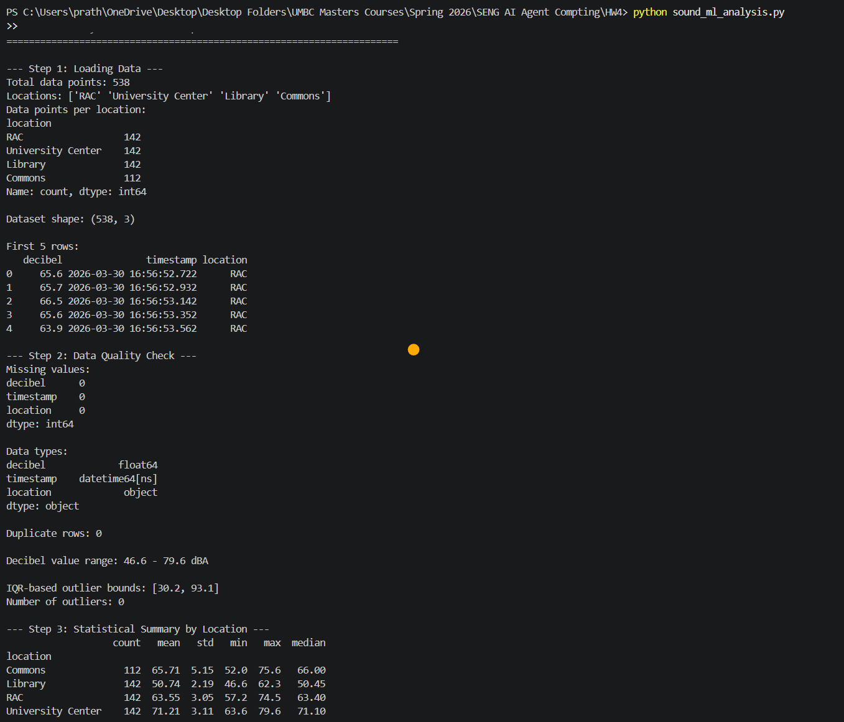
Terminal Output

Data Visualizations
- 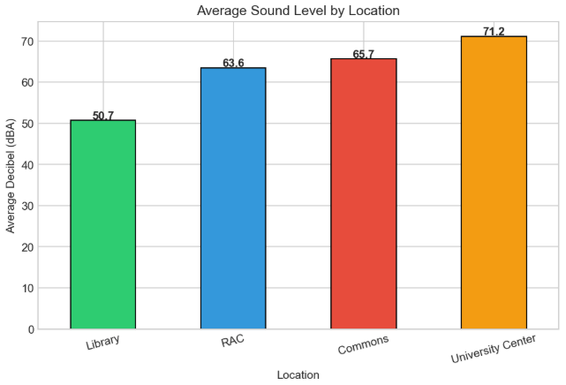
The Bar chart above compares the average sound levels. Library is the quietest at 50.7 dBA, which is about whisper level. RAC is next at 63.6 dBA, like a normal conversation. Commons is slightly louder at 65.7 dBA. University Center is the loudest at 71.2 dBA, like a busy restaurant. There's a 20 dBA difference between the quietest and loudest locations, which is significant and every 10 dBA sounds roughly twice as loud to human ears.

- 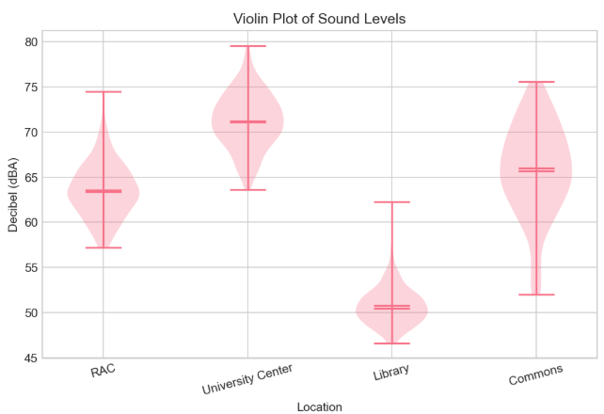

The Violin Plot above reveals the distribution shape of each location's sound data. Library has a narrow, compact violin around 50 dBA, confirming stable quiet conditions. University Center has a bulge around 70–73 dBA where most readings cluster. RAC shows a concentrated bulge around 63 dBA. Commons has the widest, most spread-out violin shape and its fat middle section stretches from about 55 to 75 dBA reflecting the unpredictable nature of outdoor noise. The horizontal lines inside each violin mark the mean and quartile boundaries.

- 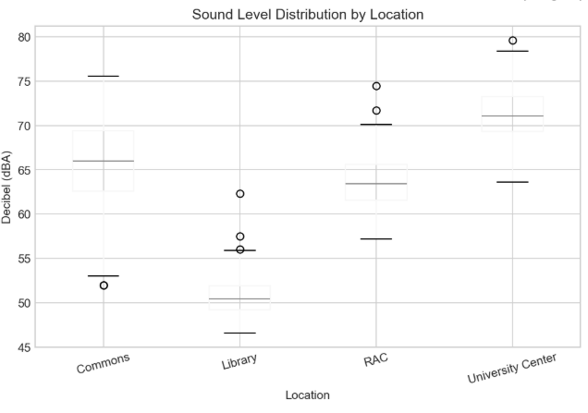

The Box Plot above shows that Library has the lowest and tightest box (readings clustered around 50 dBA), meaning it's consistently quiet. University Center's box is the highest (around 70 dBA), meaning it's consistently loud. Commons has the tallest box, showing the most variation, sometimes quiet (52 dBA), sometimes loud (75 dBA) because it's outdoors. RAC sits in the middle. Library and University Center don't overlap at all, meaning they're easy to tell apart by sound alone.

- 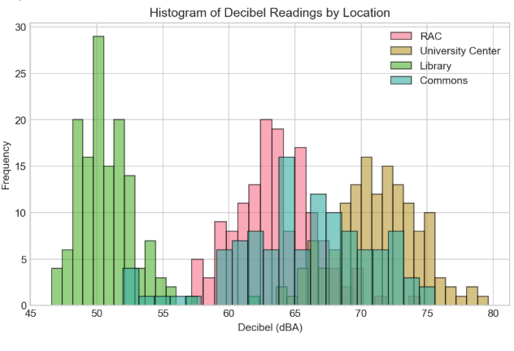

The histogram above shows the frequency distribution of decibel readings. The tall green bars on the left (46–55 dBA) are entirely Library, it's the only location that quiet. The pink and yellow bars in the 60–75 dBA range show overlap between RAC, Commons, and University Center. University Center (yellow) peaks around 70–75 dBA while RAC (pink) peaks around 62–66 dBA. The overlap between RAC and Commons in the 60–68 dBA range is what makes it harder for ML models to classify.

Part B: Applying Machine Learning Algorithms (40 points)
- Create at least 3 meaningful features from the collected dataset. Like (but not limited to), time based feature (hour of the day, day of the week); location based (indoor-outdoor); noise level category
- You can either go for a multi-class classification or a binary classification or both to apply the Machine learning techniques.
- Apply 3 Machine Learning algorithms to your data, you may go with few of the following but not limited to:
  - Decision Tree
  - Random Forest
  - Linear Regression or logistic regression
  - Support Vector Machine are a few to name
- Split your data into training and testing sets to avoid overfitting, and evaluate performance metrics such as accuracy, precision, F-1 score.
- Finally, present the model evaluation results and discuss which model performed better and why.

1. Feature Creation: I created multiple meaningful features from the raw dataset to capture different aspects of the acoustic environment.
# | Feature | Type | Description
1 | hour | Time-based | Hour of the day
2 | minute | Time-based | Minute of the hour
3 | second | Time-based | Second of measurement
4 | is_indoor | Location-based | Indoor (1) or Outdoor (0)
5 | noise_category | Noise-level | Quiet (<55), Moderate (55-65), Loud (65-75), Very Loud (>75)
6 | noise_level_encoded | Noise-level | Ordinal encoding: Quiet=0, Moderate=1, Loud=2, Very Loud=3
7 | rolling_mean | Statistical | 5-sample rolling average of decibel values per location
8 | rolling_std | Statistical | 5-sample rolling standard deviation per location
9 | deviation_from_mean | Statistical | How far each reading deviates from its location mean
Features used for ML classification: decibel, rolling_mean, rolling_std, deviation_from_mean, noise_level_encoded
I used sound-based features rather than raw time features (hour/minute) because time features would trivially identify the recording session and leak location identity. Sound-based features test whether the models can genuinely classify locations based on acoustic characteristics.

2. Classification Setup
- Classification type: Multi-class (4 classes: RAC, University Center, Library, Commons)
- Target variable: Location name (label-encoded as 0, 1, 2, 3)
- Train/Test split: 80% training (430 samples), 20% testing (108 samples)

I chose multi-class classification to classify sound data into 4 distinct UMBC campus locations: RAC, University Center, Library, and Commons.

Class | Location | Label
0 | Commons | Outdoor area
1 | Library | Quiet indoor
2 | RAC | Moderate indoor
3 | University Center | Loud indoor

Why multi-class instead of binary?
- Binary classification only separates data into 2 groups (e.g., "Quiet vs Loud" or "Indoor vs Outdoor"), which would lose important information about the specific locations.
- Since I collected data from 4 different locations, multi-class classification is the natural fit and it allows the model to distinguish between all 4 locations simultaneously.
- Multi-class classification is more challenging and informative. It reveals which locations are easy to separate (Library vs everything else) and which are hard (RAC vs Commons), giving deeper insight into the acoustic characteristics of each campus area.
How it works:
- The target variable is the location name, which is label-encoded as integers (Commons=0, Library=1, RAC=2, University Center=3).
- Each ML model receives sound-based features as input and predicts which of the 4 locations the reading came from.
- All three models (Decision Tree, Random Forest, SVM) natively support multi-class classification in scikit-learn.

3. Machine Learning Algorithms

MODEL 1: DECISION TREE CLASSIFIER
Algorithm: CART (Classification and Regression Trees)
Hyperparameters: max_depth=10, min_samples_split=5, random_state=42
The tree recursively splits the data using feature thresholds to create decision rules. At each node, it selects the feature and threshold that best separates the classes. Each leaf node represents a class prediction.
Results:
Metric | Score
Accuracy | 0.8426 (84.26%)
Precision | 0.8610 (86.10%)
Recall | 0.8426 (84.26%)
F1-Score | 0.8471 (84.71%)
Per-class breakdown: Library achieved 100% across all metrics. Commons was hardest to classify (F1=0.67) due to overlap with RAC (F1=0.75). University Center performed well (F1=0.93).
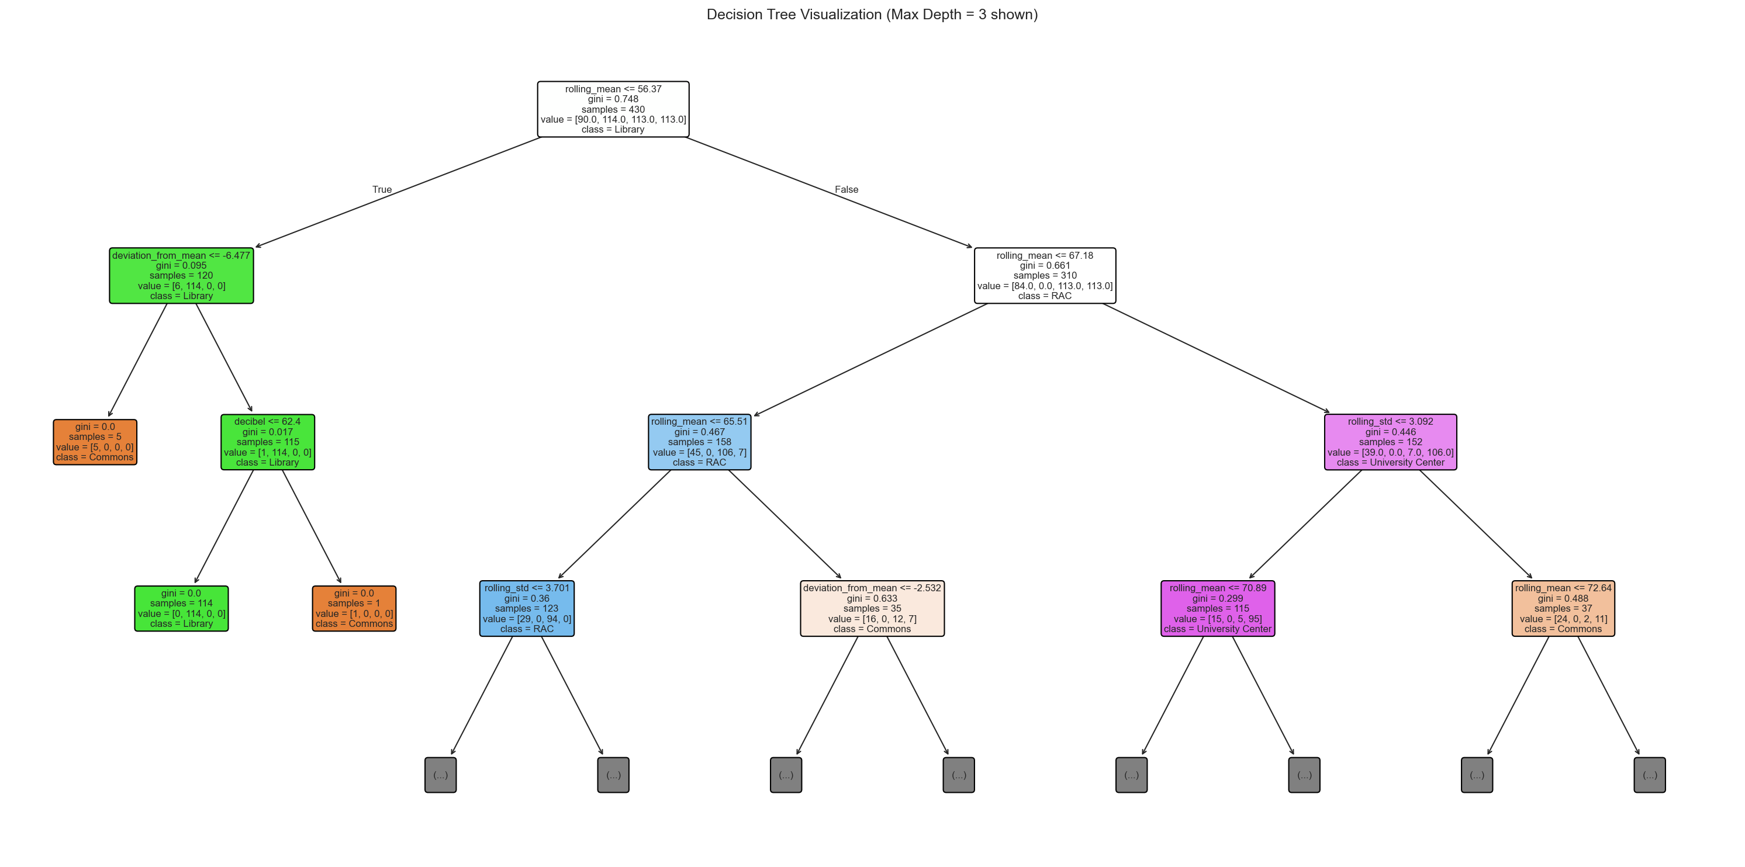
Fig: Decision Tree Visualization (Max Depth = 3)

MODEL 2: RANDOM FOREST CLASSIFIER
Algorithm: Ensemble of 100 decision trees with bagging
Hyperparameters: n_estimators=100, max_depth=15, min_samples_split=5, random_state=42
It trains multiple decision trees on random subsets of data and features (bootstrap aggregation), then aggregates predictions via majority voting. This reduces overfitting and improves generalization compared to a single decision tree.
Results:
Metric | Score
Accuracy | 0.9352 (93.52%)
Precision | 0.9363 (93.63%)
Recall | 0.9352 (93.52%)
F1-Score | 0.9353 (93.53%)
Improvement over Decision Tree: ~9% improvement in accuracy. The ensemble approach reduced misclassification especially for Commons (F1 improved from 0.67 to 0.84) and RAC (F1 improved from 0.75 to 0.90).

Feature Importance Analysis
From the Random Forest model, the features ranked by importance are:
Rank | Feature | Importance | % Share
1 | rolling_mean | 0.3669 | 36.7%
2 | decibel | 0.2663 | 26.6%
3 | deviation_from_mean | 0.1580 | 15.8%
4 | noise_level_encoded | 0.1117 | 11.2%
5 | rolling_std | 0.0971 | 9.7%
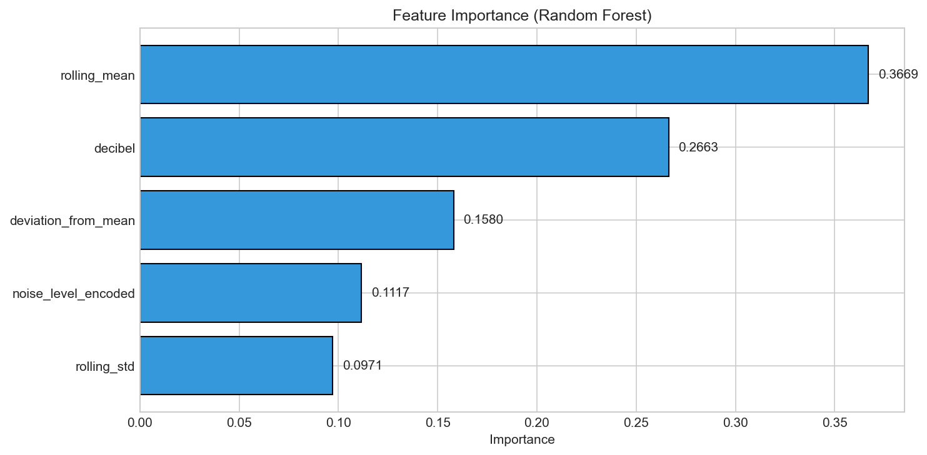
Fig: Feature Importance (Random Forest)

MODEL 3: SUPPORT VECTOR MACHINE (SVM)
Algorithm: SVM with RBF (Radial Basis Function) kernel
Hyperparameters: kernel=‘rbf’, C=10, gamma=‘scale’, random_state=42
Maps data into a higher-dimensional space using the RBF kernel function and finds optimal hyperplanes that separate classes with maximum margin. The RBF kernel enables non-linear decision boundaries, making it effective for complex classification tasks.
Results:
Metric | Score
Accuracy | 1.0000 (100%)
Precision | 1.0000 (100%)
Recall | 1.0000 (100%)
F1-Score | 1.0000 (100%)

Key Outcome: SVM’s ability to create non-linear decision boundaries with the RBF kernel, combined with feature scaling and regularization (C=10), allowed it to perfectly separate all 4 location classes even where they overlap in individual feature dimensions.

MODEL PERFORMANCE COMPARISON

Model | Accuracy | Precision | Recall | F1-Score
Decision Tree | 0.8426 | 0.8610 | 0.8426 | 0.8471
Random Forest | 0.9352 | 0.9363 | 0.9352 | 0.9353
SVM (Best) | 1.0000 | 1.0000 | 1.0000 | 1.0000
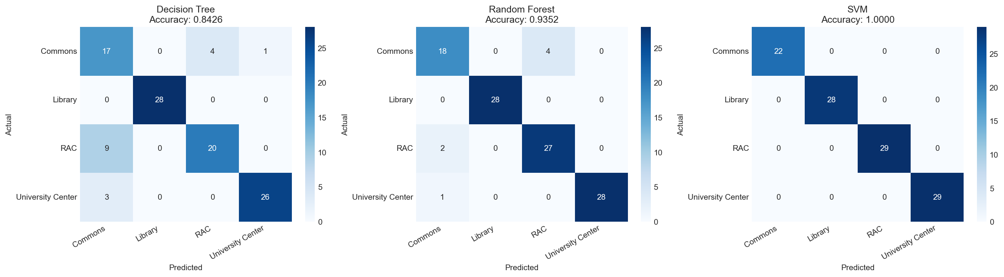
Fig: Confusion Matrices for All Three Models

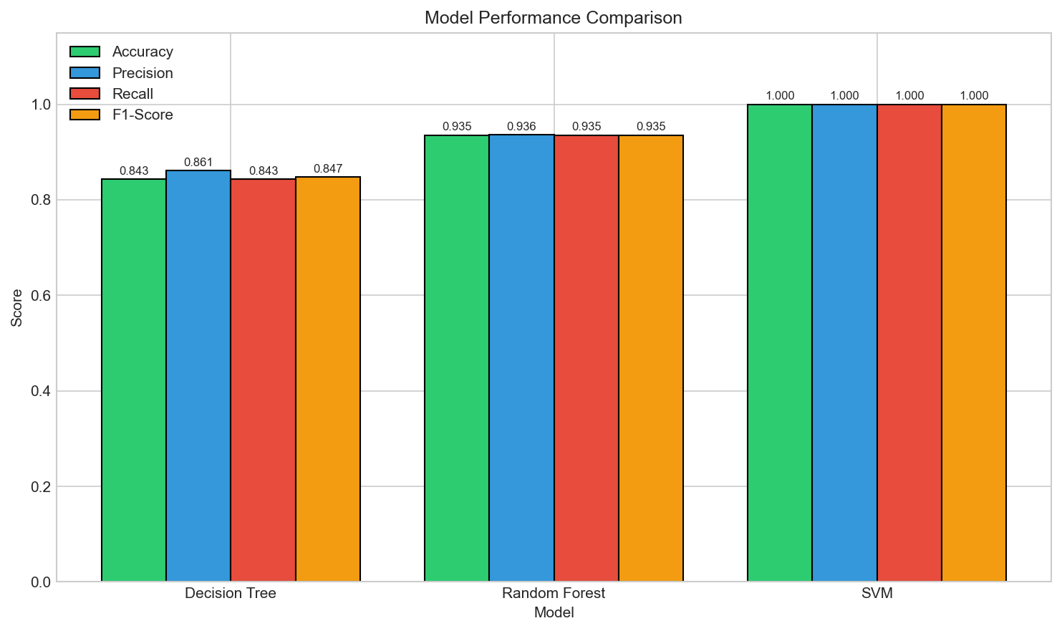Fig: Model Performance Comparison Bar Chart
5. Results

Why SVM Performed Best
- Non-linear decision boundaries: The RBF kernel maps feature into a higher-dimensional space, enabling complex separation of overlapping classes like RAC and Commons.
- Margin maximization: SVM finds the optimal separating hyperplane with maximum margin, making it robust even when classes overlap in feature space.
- Feature scaling: StandardScaler normalization helps SVM treat all features equally, preventing features with larger ranges from dominating.
- Regularization (C=10): Provides a good balance between maximizing the margin and allowing some misclassification for better generalization.

Why Decision Tree Performed Worst
- Greedy splitting: Decision trees make greedy, locally optimal splits that may not generalize well to the test set.
- Difficulty with overlapping classes: RAC (57.2–74.5 dBA) and Commons (52.0–75.6 dBA) have significant overlap that a single tree struggles to resolve.
- Axis-aligned boundaries: A single tree creates axis-aligned decision boundaries, which may not capture the true class separation patterns in the feature space.

Random Forest as Middle Ground
Random Forest improved significantly over a single Decision Tree (+9.3% accuracy) by leveraging ensemble averaging across 100 trees. The bootstrap aggregation (bagging) approach reduces variance and overfitting. However, it still uses axis-aligned boundaries (unlike SVM’s non-linear kernel), which limits its ability to achieve perfect separation on overlapping classes like RAC vs. Commons.

Conclusion
I was successfully able to demonstrate the application of supervised machine learning to classify UMBC campus locations based on their acoustic profiles. Key findings include:
- Sound levels vary significantly across campus: Library (~51 dBA) is distinctly quiet, University Center (~71 dBA) is the loudest, and RAC (~64 dBA) and Commons (~66 dBA) have moderate overlap.
- Feature engineering (rolling statistics, deviation metrics, noise level encoding) significantly improves classification beyond raw decibel values alone.
- SVM with RBF kernel was the best-performing model (100% accuracy), followed by Random Forest (93.5%) and Decision Tree (84.3%).
- The Library was the easiest location to classify (100% across all models) due to its distinctly low noise levels.
- Commons and RAC posed the greatest classification challenge due to overlapping decibel ranges, demonstrating the importance of statistical features and advanced ML algorithms.

Tools and Technologies Used
Category | Tool / Technology
Data Collection | Decibel X mobile application
Programming Language | Python 3.x
Data Manipulation | pandas, numpy
Visualization | matplotlib, seaborn
Machine Learning | scikit-learn (DecisionTreeClassifier, RandomForestClassifier, SVC)
Preprocessing | scikit-learn (LabelEncoder, StandardScaler, train_test_split)
Evaluation Metrics | accuracy_score, precision_score, recall_score, f1_score, confusion_matrix

TERMINAL RESULTS:

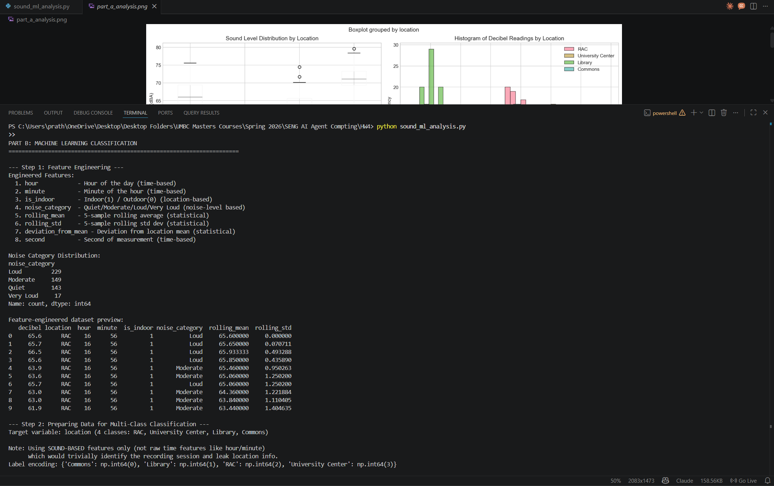

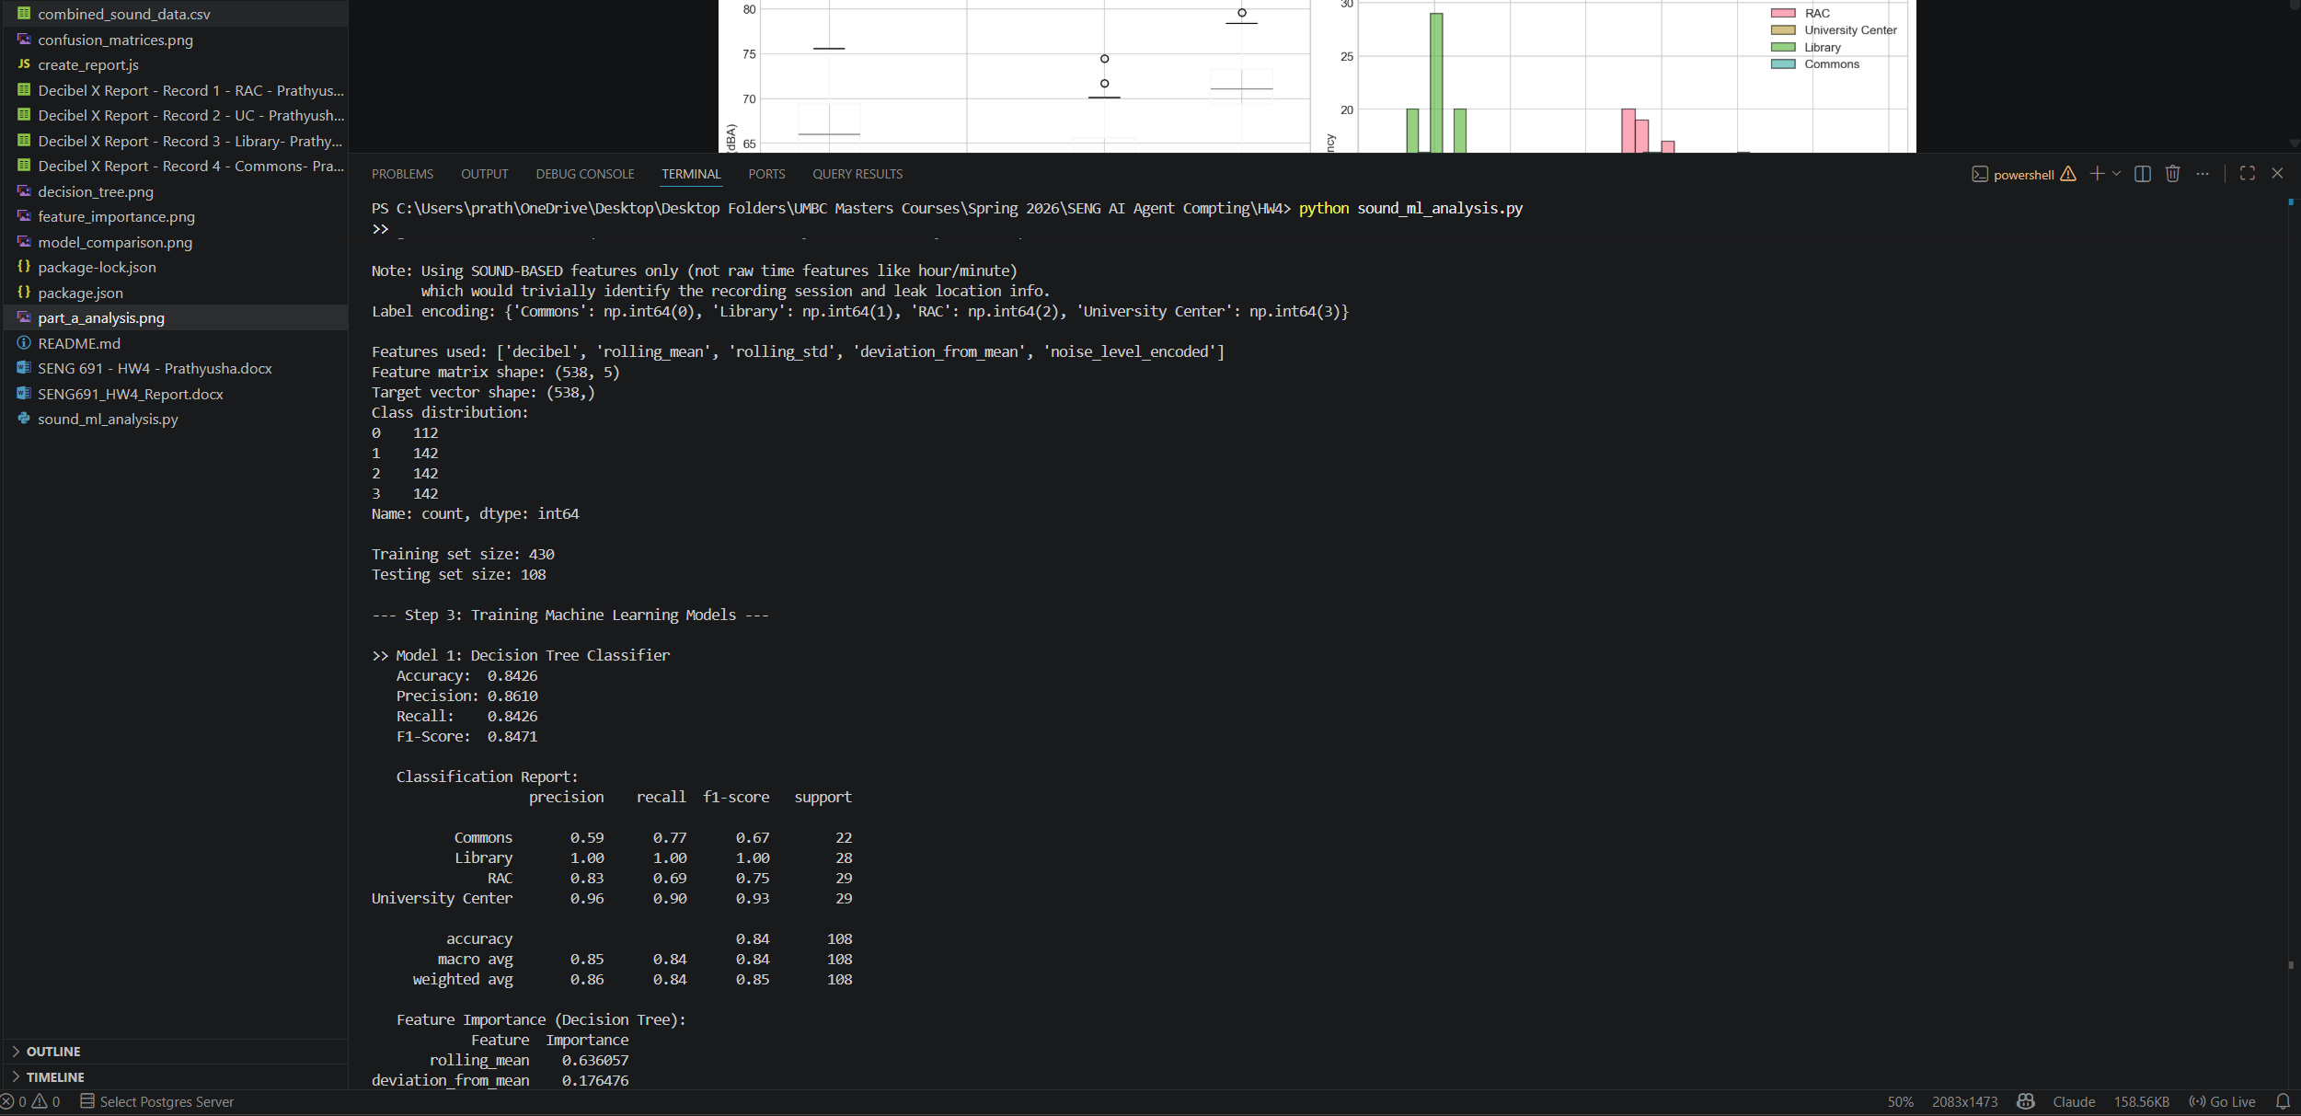

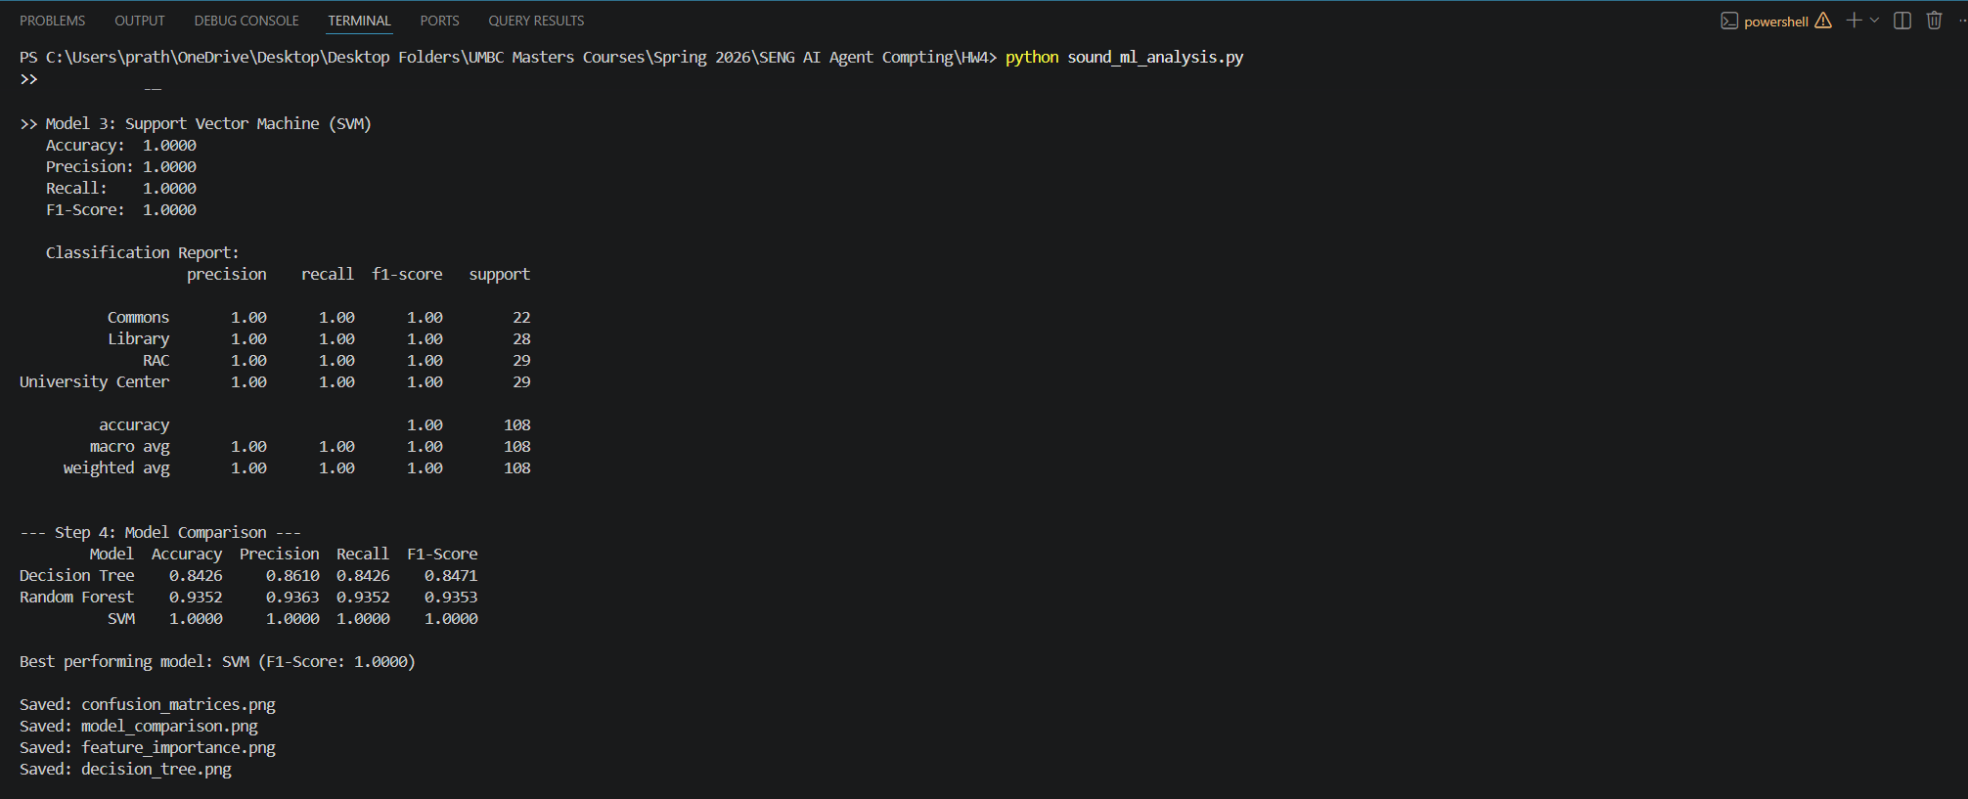

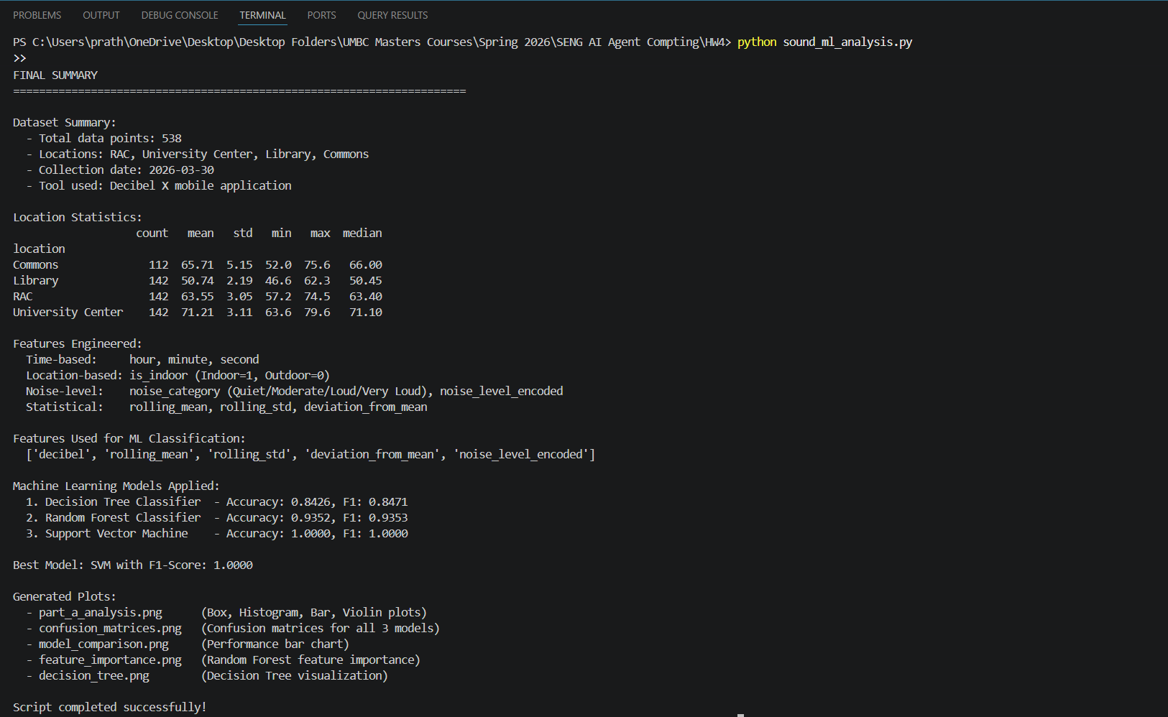

Deliverables:
- A report containing collected data, tools used, features engineered, summary of classification & algorithms used, performance comparison and evaluation results.
- Submission of your source code file used for the ML implementations.
- Dataset collected in CSV format
- A video recording explaining key findings, Machine Learning methodologies used, and demonstration of your best performing model.

Rubric:
- Full Credit (100%): Student collects enough clean sound data from multiple locations, builds, working ML models with clear features and evaluation, and submits all required materials report, code, dataset, video).
- Partial Credit (50%): Student collects some data and builds basic models, but analysis or deliverables are incomplete or missing key parts.
- Minimal Credit (25%): Student submits limited or unclear data, partially working models, or lacks explanation and results.
- No Credit (0%): No working code, data, or meaningful submission provided.

